Study Skills- Essay writing

- Use mind mapping to brainstorm and organise.
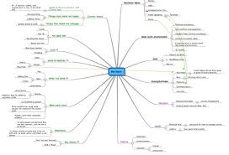
- Use post it notes to get as many thoughts down as quickly as possible, you can then organise and move at a later time. Take each idea on each post it note and write it into a paragraph.
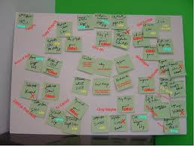
- Outline introduction and end- plot out how to move through from the introduction through stages
to the end.
- Proof read out loud to see if you hear mistakes. Check work for one aspect at a time- spelling, grammar etc

Study Skills- Study tips

- Draw funny, colourful cartoon pictures that show a certain phrase or word you have difficulty in remembering.

- Texting: whenever you and your friends text- add a revision question at the end, get them to
text you one back.

- Revision timetable/ To do list – how long it will take you? when you are going to do it?

- Abbreviations Learn how to take notes / use abbreviations

- Question cards
Make up some question cards with questions on the front and answers on the back! Then make
a right, an almost, and a wrong pile. Keep going through the questions till they are all in the right pile.
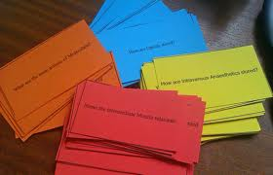

- Hand-outs from class- take these and summarise on the day of the lesson/ when you get home, even if you just highlight key vocab/ points – all too easy to read and not remember!

- Review class notes etc when you get home – forgetting is greatest within 24 hours if
you do not review. If you don’t understand when you get home– remember to ask during the
next lesson/ LSA/ Class teacher………… several weeks later before a test you certainly won’t.

- Key vocab Ensure students have a list of key subject – specific words for topic that they
understand.

- Blocks of study time
Develop blocks of study time – about 50 mins? How long does it take before you become restless?
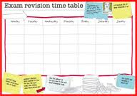

- Take notes in class – write down as many notes as possible this will force you to pay attention to what’s going on in class it will keep you awake there will be less you need to remember

- Create visual images and families to help storage. eg chronology change the o into a clock.

- Number peg system
Learn the following system
- bun
- shoe
- tree
- door
- hive etc
Then when remembering facts etc transport, river, bridge etc- pupils need to link each fact to a number link
Eg transport / bun – pupils try to visualise a mental picture i.e lorry containing bun picture on
the side

- Telling a story
Pupils to place the key elements to remember into story. i.e the woman was cooking with the
heat turned high, the flame reacted with the copper pan and changed to blue.

- Mnemonics
A mnemonic is a word or rhyme that helps you to remember a fact or a spelling
Every Good Boy Deserves Football for the EGBDF notes on a music line.

- Colour code notes- major points, sub sections and key points
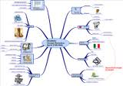

- Photocopy your summary notes and swap / email with peer – they often have recorded things
in a different manner.

- Video’s Make short revision video’s – upload on You tube / Power point–share with your friends and divide the work. Between you to ensure there is a video for each subject area.

- Colours Rewrite your summary notes using different colours / fonts- use different colours, types
of pens.

- Spelling
Make sure you can spell key words- make yourself a spelling list that a family member can test
you on. Test yourself using ‘read, cover up, write and check’.

- Rap
Be active when testing yourself – add in an action or link to a rap

- Exam papers
Do past exam papers/do past exam papers – timed

- Essay plan
Practice forming an essay plan

- Exercise between revising

- Use post it notes – place them in unexpected areas- look at key facts while cleaning teeth etc

- Use TV programmes / BBC Bite Size/ revision websites/ podcasts
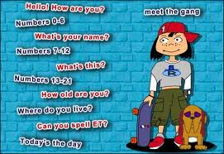

- Index cards
For each topic, write up one set of index cards with the word on the front, and the definition on the back. Shuffle them and drill yourself. Take turns with a classmate testing each other.
- Don't just copy out your notes. Jot ideas onto postcards. Draw diagrams too - they're easier to remember in the heat of the exam.

- Don't go it alone! They say a problem shared is a problem halved. So, get friends and family on board: put a copy of your revision timetable up in the kitchen. Get your family to test you on physics facts and that awkward French vocabulary!
Explain a concept to friend / family member who has limited knowledge.
Can family / LSA/friends give pupils one question a day?

- The smaller and smaller method
What you need: an A4 sheet of paper, an A5 sheet of paper and a postcard
What to do: First, write out the key topics onto your A4 paper. Fit as much on as you can. Then,
take only the important bits and copy the information onto the A5 piece. Try to fit it all on!
Condense it again onto the postcard. You should now have only the very important words left.
How to extend it: Can you get all the important points on the back of a business card?

- W- what, when, why, how, where and who

- Equipment- Pupil has two pencil cases – one for school stays in school bag – one at home for homework. Parents to replace any missing items in school pencil case every weekend.

- School box
Have a ‘school box’ in the home – if anything is found in the home linked with school the object
is placed in the box, so a pupil can look in the box first for a lost item.

