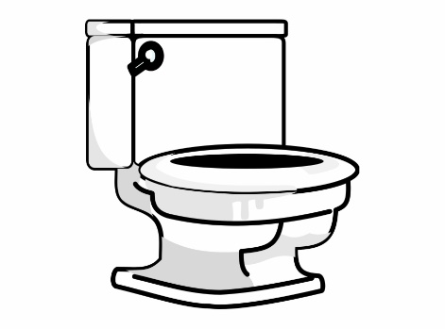Tips for Toileting

If your child has an additional need such as delayed speech or is nonverbal it doesn’t mean they can’t be potty trained, it just may take a little longer. The process can be helped along for your child by putting into place some simple strategies.

<https://www.eric.org.uk/blog/potty-training-children-with-communication-challenges>

Preparation

* Complete bowel & bladder assessment <https://www.eric.org.uk/Handlers/Download.ashx?IDMF=e5411211-d238-4003-927a-46a613aafec4> referring also to the poo chart below. It will help you to understand your child’s pattern of toilet habits and you can then create a potty or toilet routine based on this information.
* Keep a close eye on bowel movements. Your child should pass a soft poo (number 4 on the chart at least 4 times a week, but not more than 3 times a day. If their poo is hard or persistently loose (number 7), they could be constipated. This will have an impact on the success of the toileting plans and should be discussed with your GP.
* Your child will need to be able to hold their wee for 1 – 2 hours e.g. while they nap. Dry nappies will indicate readiness

Ready to begin

* Once you decide to go for it, ditch the nappies or pull ups (except for night time) and don’t look back.
* Ensure you have plenty of spare underwear. Use loose fitting clothing e.g. tracksuit bottoms, leggings or shorts for ease and speed and encourage your child to help with lowering and raising these as part of the routine.
* Do not ask if your child if he/she ‘needs’ or ‘would like’ to go to the toilet, but keep to regular toilet times. 15-20 mins after meals is often a good time.
* Use visuals (picture or object) to help your child understand what is happening and keep them in an easily accessible place so that your child can eventually use them to ask.
* [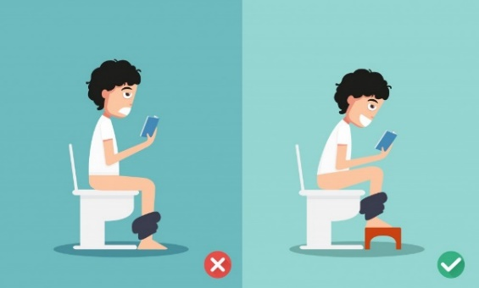](https://www.google.com/url?sa=i&url=https://www.evidentlycochrane.net/feet-up-constipation/&psig=AOvVaw1LIbnAFVVG8Wj4bF3Exmc_&ust=1585731385979000&source=images&cd=vfe&ved=0CAIQjRxqFwoTCNjt3fGrxOgCFQAAAAAdAAAAABAF)Ensure your child is relaxed in the bathroom and can sit comfortably on the potty/toilet with their feet on the floor or supported with a step, knees slightly raised and body leaning forward.

A big toilet with a large hole can be scary. Consider buying a child size seat.

* Encourage your child to sit for 1 min for every year of life in order to relax and allow the functions to happen. Use a range of ‘toilet’ toys to keep them occupied if necessary eg. Book, bubbles, singing, sensory toy.
* Accidents are to be expected, be patient, keep calm and carry on.
* Refer to [www.eric.org.uk](http://www.eric.org.uk) if you need additional advice or support.

[](https://www.google.co.uk/url?sa=i&url=https://emojiisland.com/products/poop-emoji-icon&psig=AOvVaw2ev3bzcg9PVLLvkfbl7ZeJ&ust=1585727536577000&source=images&cd=vfe&ved=0CAIQjRxqFwoTCKDMksadxOgCFQAAAAAdAAAAABAE)

Good luck!