Token board

I can get ticks towards:
Listening 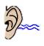
Looking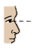
Hands still 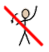
Using my words