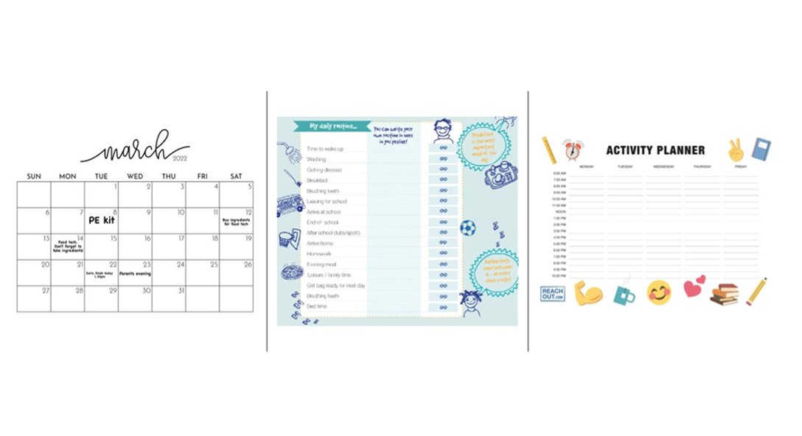Routines and organisation

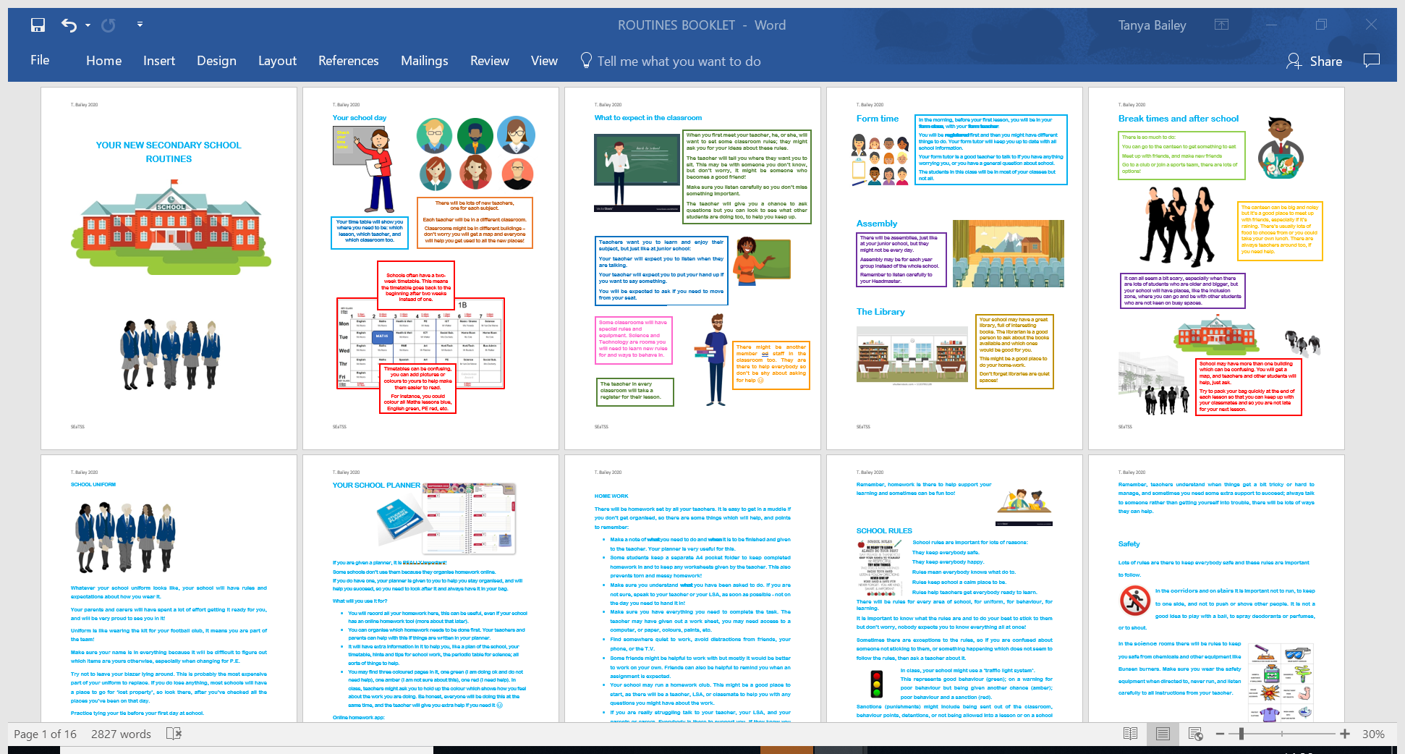

**Links for organisation and routines:**

[Supporting your Child's organisation - YouTube](https://www.youtube.com/watch?v=e4jkqN_GcXk&list=PL7MVghDNLeJwbHR7INOmS8dTOzO9bKeJu&index=1)

[Organizing Tips | 10 Ideas to Help Get Your Child Organized | Understood](https://www.understood.org/en/articles/10-tips-to-help-get-your-child-organized)

[How can I support my child? - British Dyslexia Association (bdadyslexia.org.uk)](https://www.bdadyslexia.org.uk/advice/children/how-can-i-support-my-child)

[Establishing Routines Home Routines and Organisation Tools - - Page 8 (twinkl.co.uk)](https://www.twinkl.co.uk/resources/wellbeing-parents/parents-home-routine-and-timetable/establishing-routines-home-routines-and-organisation-tools-health-wellbeing-parents/8)

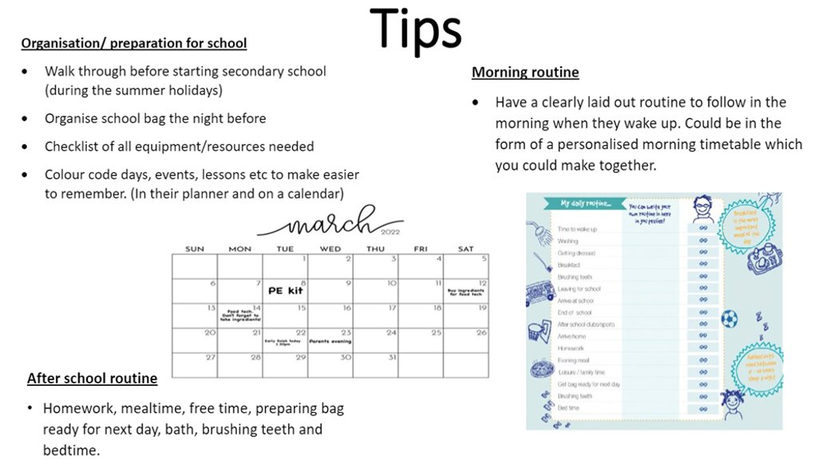

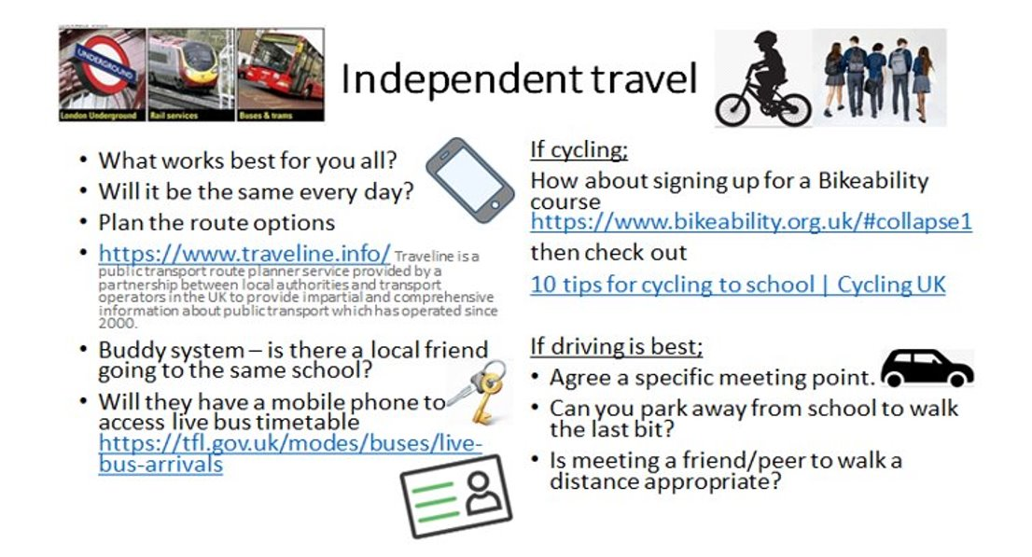

Independent travel

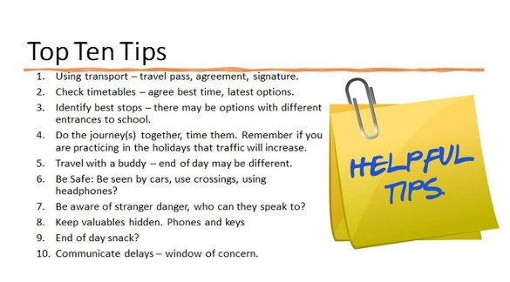

**Links for travel:**

<https://www.traveline.info/>

<https://tfl.gov.uk/modes/buses/live-bus-arrivals>

<https://www.bikeability.org.uk/#collapse1>

[Keeping children safe at school | NSPCC](https://www.nspcc.org.uk/keeping-children-safe/away-from-home/at-school/" \l "homealone)

[600 Top Supporting Independent Travel To Secondary School Teaching Resources (twinkl.co.uk)](https://www.twinkl.co.uk/search?q=supporting+independent+travel+to+secondary+school&c=244&r=parent)



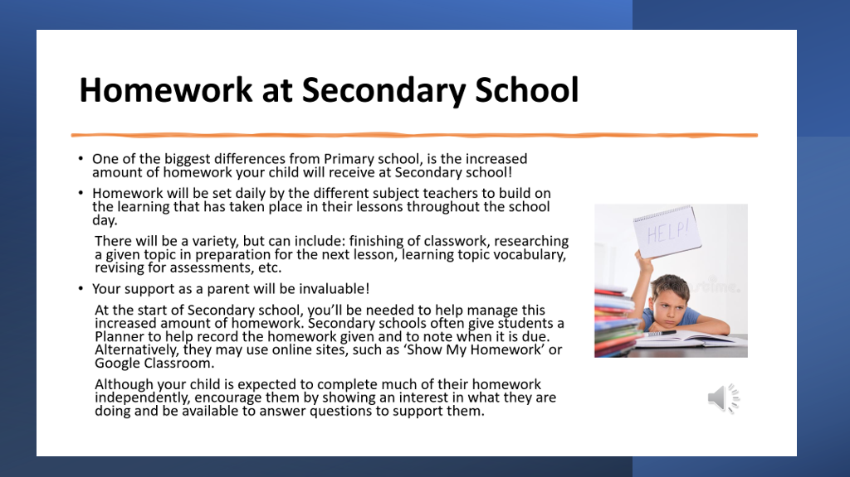Homework

**Links for homework:**

[How Can I Support My Child with Homework at Secondary School? (twinkl.co.uk)](https://www.twinkl.co.uk/blog/how-can-i-support-my-child-with-homework-at-secondary-school)

[Parentkind - Supporting homework](https://www.parentkind.org.uk/Parents/Supporting-homework)

[How can I Help my Child with Homework? (educationquizzes.com)](https://www.educationquizzes.com/knowledge-bank/how-can-i-help-my-child-with-homework/)

[Homework - British Dyslexia Association (bdadyslexia.org.uk)](https://www.bdadyslexia.org.uk/advice/children/how-can-i-support-my-child/homework)

[How do I... help my child deal with homework? (ndcs.org.uk)](https://www.ndcs.org.uk/information-and-support/parenting-and-family-life/families-magazine/how-do-i/how-do-i-help-my-child-deal-with-homework/)

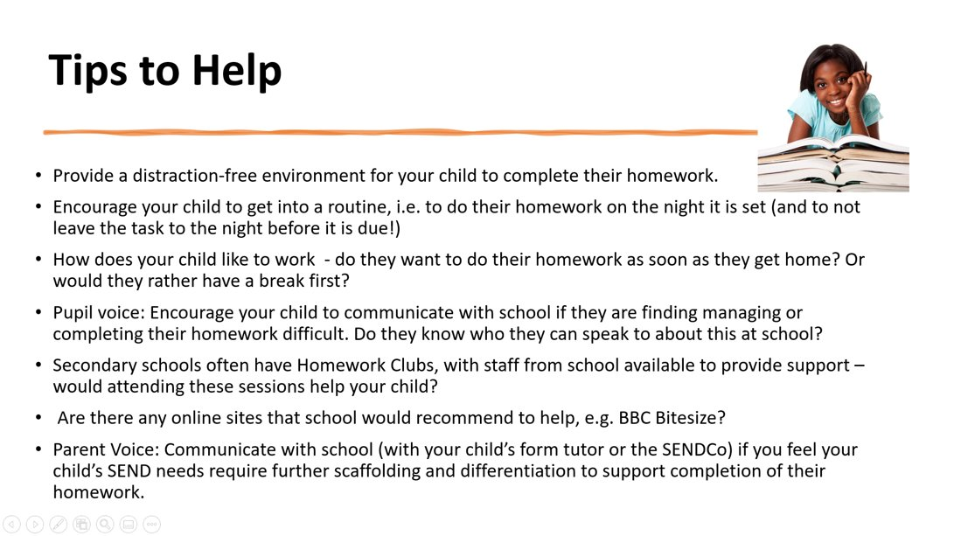

Anxiety

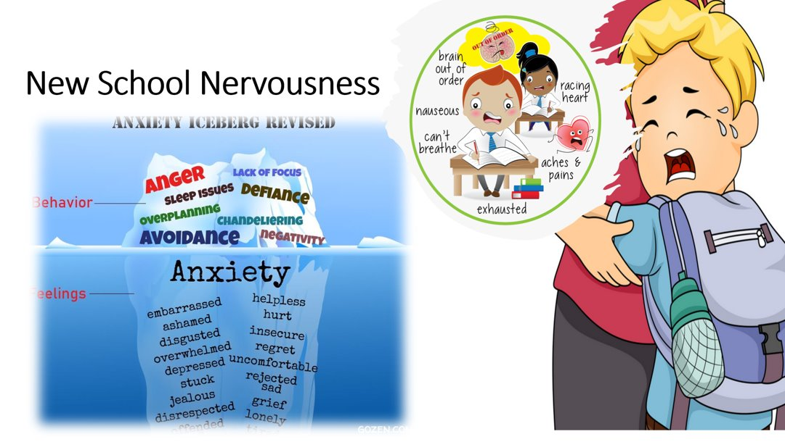

**Links for anxiety:**

[School Resources to Help With Transitions | Mental Health | YoungMinds](https://www.youngminds.org.uk/professional/resources/supporting-school-transitions/)

[Transition to primary school – Place2Be](https://www.place2be.org.uk/our-services/parents-and-carers/getting-ready-to-start-primary-school/)

[Navigating exam season resources - Place2Be](https://www.place2be.org.uk/our-services/services-for-schools/navigating-exam-season-free-resources/)

