Using cutlery

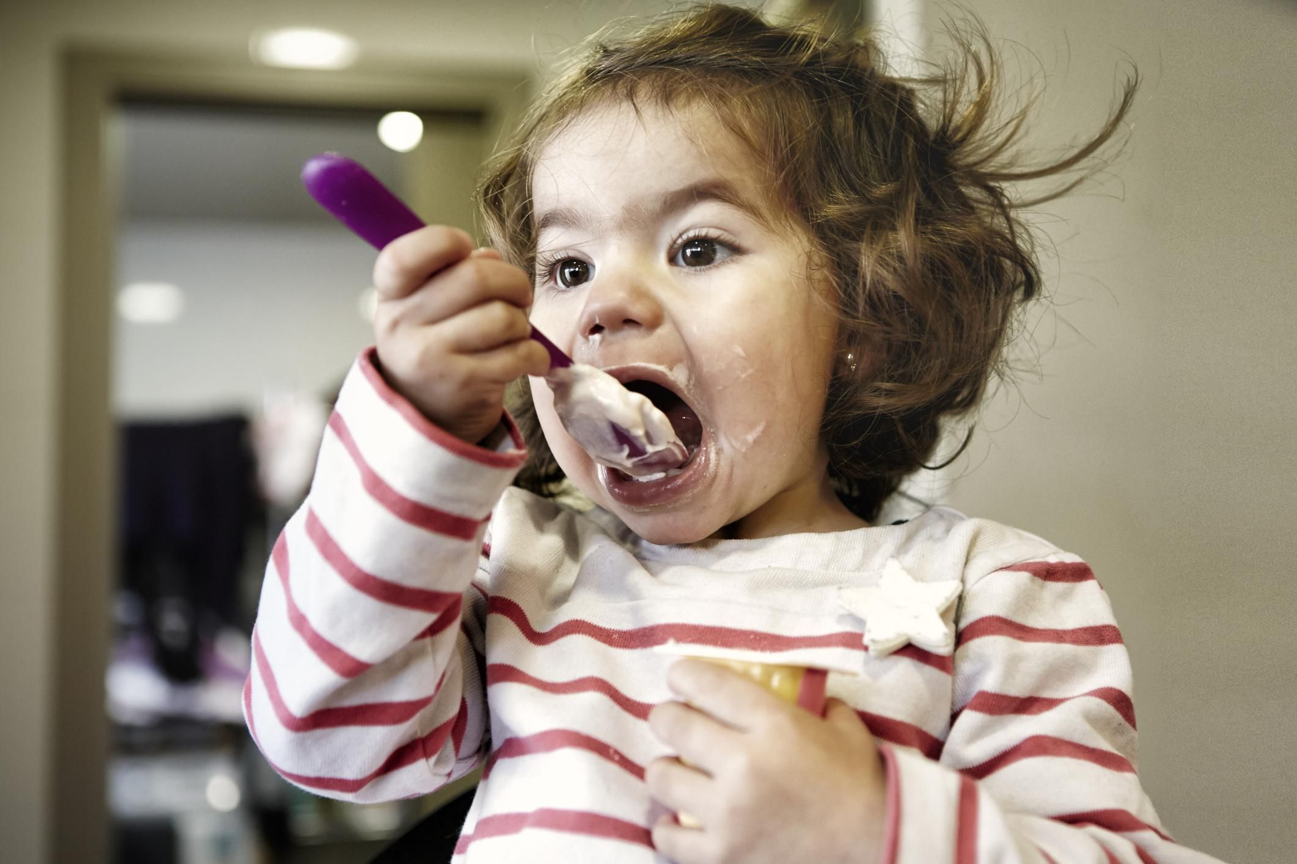

Key words

* Cut
* Hold
* Two hands
* Saw
* Scoop

Games to play

Cutting & play wooden food

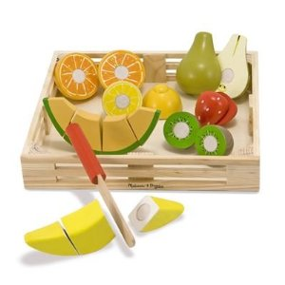

Cutting a banana with knife

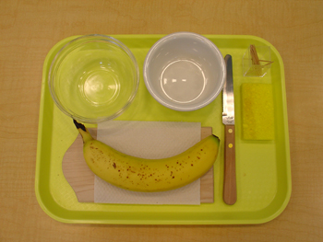

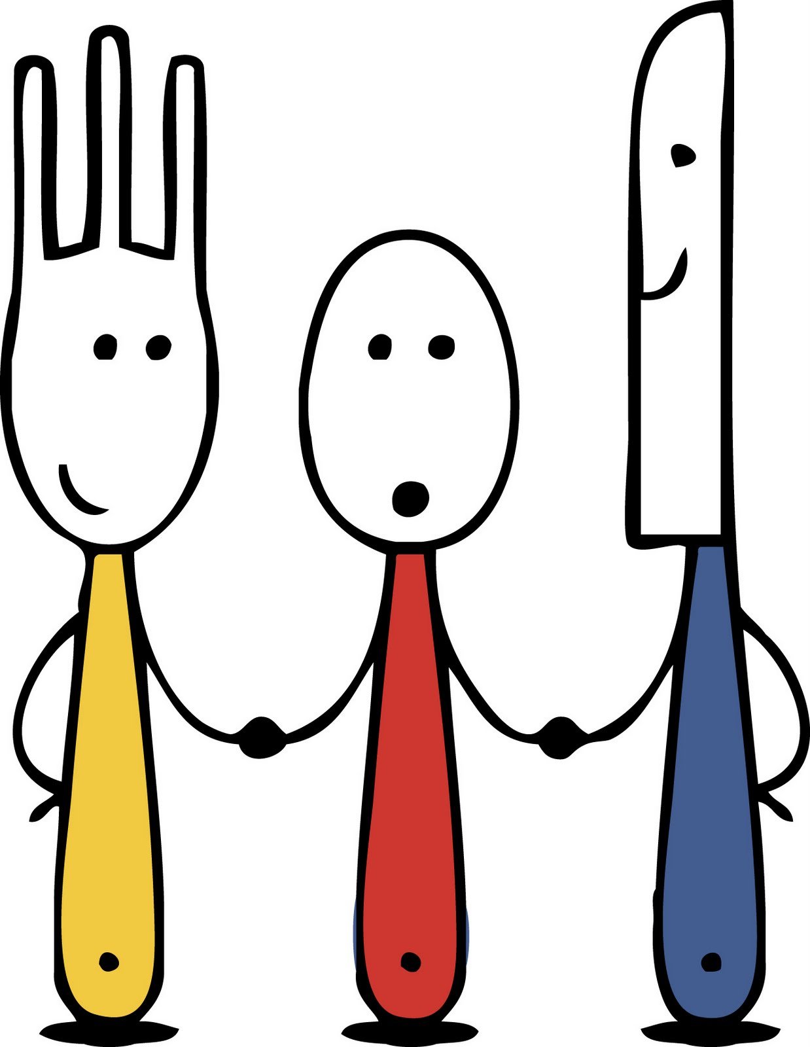

Songs/videos to use

**Miss Smith’s video from School lunchtime**

* <http://bit.ly/2mmsdn3>

**Table manners**

* <http://bit.ly/1PCfeWH>

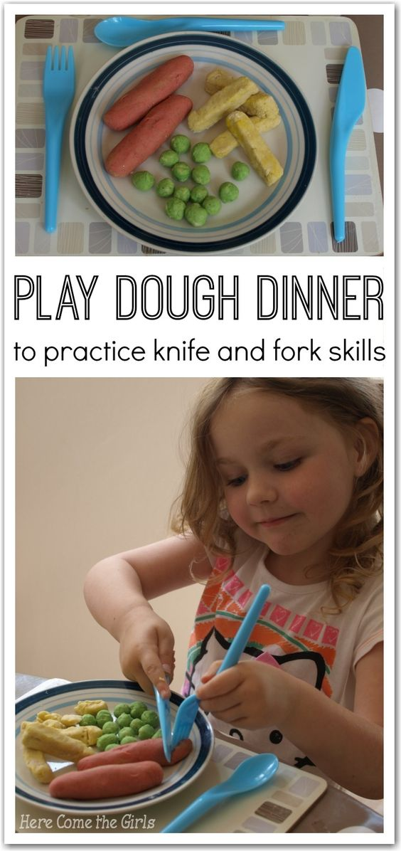

How to do teach it-handout

* <http://www.wikihow.com/Use-Cutlery>

Social Story

* <https://www.mystorybook.com/books/239473>

Fussy eater?

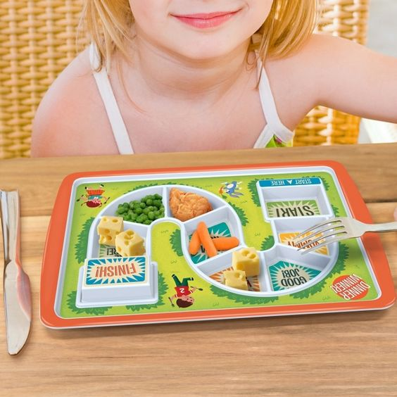

Newbridge Outreach Service [www.redbridgeserc.org](http://www.redbridgeserc.org) www.redbridgeserc.org

Caption describing picture or graphic.

Page 2

A favorite family phrase or slogan can go here.