Washing your hands

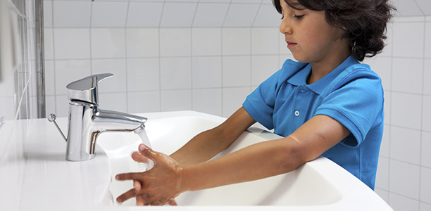

Key words

* Wipe
* Wash
* Rub together
* Rinse
* Clean
* Dirty
* Dry

Free Sesame Street handwashing handouts

<http://bit.ly/2lExxDz>

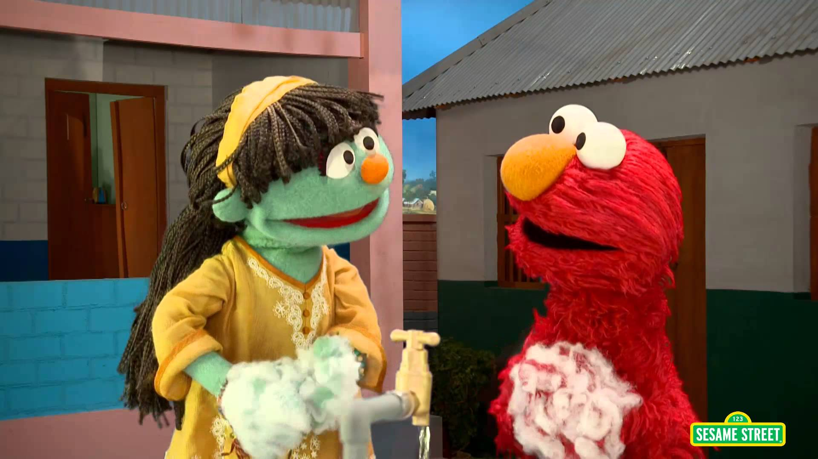

Songs to use

Carex Hand Washing songs

<http://www.carex.co.uk/handwashing-songs>

Washy Washy Clean Scrub Scrub

<http://bit.ly/1cBlnli>

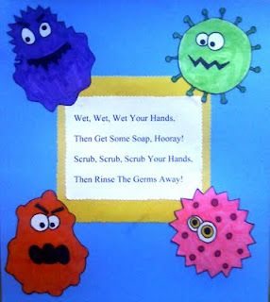

How to do teach it-handout

* <http://www.wikihow.com/Teach-Kids-to-Wash-Their-Hands>

**Free resources for Teachers and Families**

* <http://www.carex.co.uk/teacher-zone>

Social Story

* <http://bit.ly/2m357iQ>

Symbols

* <https://livingwithanautisticchild.com/visual-schedule/>

Newbridge Outreach Service [www.redbridgeserc.org](http://www.redbridgeserc.org) www.redbridgeserc.org

Caption describing picture or graphic.

Page 2

A favorite family phrase or slogan can go here.