|  |  |  |  |  |  |  |  |  |  |
| --- | --- | --- | --- | --- | --- | --- | --- | --- | --- |
| Week **1** learning at home timetable | Breakfast | Maths | **Activity 1** | Reading/Phonics | Writing **See handwriting reminder sheet.** | **Afternoon activity 2** | **Afternoon activity 3** | Play | Reading before bed time |
| Monday | **Breakfast**  **Embed language across the day i.e attributes about objects**  **-Texture**  **-Size**  **-Length**  **-Volume**  **-Weight**  **-Colour**  **-Sorting into categories**  **-Comparing objects** | **Home learning booklet:** multiplication & division unit 3 and 4 times tables  **Challenge:**  1) Write the names of 10 friends which you will invite to a party. If you had 40 sweets to give out equally, how many sweets will each of your friends have? Draw their plates.  2) What’s for dinner tonight? Is there anything which needs to be divided equally between everyone eating at home? | **Yoga/Meditation:**  Practice taking time out of your day to focus on your breathing and your body.  **Youtube:** Cosmic Kids Yoga | Practice speed sounds every day.  Write sounds on small pieces of scrap paper, ask someone to hide it around the house. Each time you find a sound, you need to write a word including the sound i.e if you find ‘ire’, you can write the word ‘fire’ and then go and find the next sound!  Underline the special friends you notice in the book you read.  Spell sounds out on your fingers  When you read, try and sound talk in your head before you say the whole word. | **Diary entry** – Write about yourself, include what you look like, your personality & what you love to do | **Board / card games**  Make up your own card game  Play a board game and change the rules | Help with cooking  Take measurements of ingredients you add, what do you notice?  **Take a look:**  Check out the expiry date of items in your fridge, take a note & let someone know if they’re nearly expiring | Reduce screen time before bed time | Add this to your weekly schedule, so children continue to recognise words, build fluency when reading and practice their phonics knowledge. |
| Tuesday | **Home learning booklet:** multiplication & division unit 3 and 4 times tables  **Challenge:**  Ask someone to hide the 3D shape cards in the house, when you find them, match it to something in the house which is the same shape.  Or  Play I-spy with my little eye using 3D shapes i.e ‘ I spy with my little eye, something which is a cube’ **\* see worksheet** **too** | **Board games**  Play your favourite board or card game, how will you change this game to make it even better? | **Instructions:** Write instructions about the game you played earlier or your favourite game for an alien. Be specific! | Rock painting: Find some smooth rocks and decorate them  Painting  Mindful colouring  Craft  Oragami  Bean mosaics  make slime | Make your own wordsearch include the name of people in your family  *see blank wordsearch |  |
| Wednesday | **Home learning booklet:** multiplication & division unit 3- and 4-times tables  **Challenge:**  Use your feet to measure two rooms. Compare footsteps.  Use a ruler to measure items in your home, if you do not have a ruler, you can print one out from the resource document  Order items into height order | **Art:**  Draw a mythical creature, that has powers. | **Annotate the picture of your drawing, using adjectives\*** | **Youtube:** Cosmic Kids yoga  **Website:** Go noodle | **Vlog**  Introduce /draw a picture of everyone in your house |  |
| Thursday | **Home learning booklet:** multiplication & division unit 3 and 4 times tables  **Challenge:**  Take a look at some change, organise the change to the lowest value to the highest.  or  Ask someone to hide change around the house & go on a money hunt! You have to say what you found to be able to go onto find the next coin. What will the prize be?  or list the snacks you want for snack time & ask someone to write a price list.  Use the coins to buy your snack! | **Science:**  Walk around the house / garden, record a video about the different textures you see in your environment or draw pictures of them | Organise what you saw this morning during the science activity into a table using titles i.e  “[rough](https://simple.wikipedia.org/w/index.php?title=Rough&action=edit&redlink=1)” – carpet , “[smooth](https://simple.wikipedia.org/w/index.php?title=Smooth&action=edit&redlink=1)”, - table “[hard](https://simple.wikipedia.org/w/index.php?title=Hard&action=edit&redlink=1)”, “[soft](https://simple.wikipedia.org/w/index.php?title=Soft&action=edit&redlink=1)”, “[liquid](https://simple.wikipedia.org/wiki/Liquid)”, “[solid](https://simple.wikipedia.org/wiki/Solid)”, “[lumpy](https://simple.wikipedia.org/w/index.php?title=Lump&action=edit&redlink=1)”, “[gritty](https://simple.wikipedia.org/w/index.php?title=Grit&action=edit&redlink=1)” | **Science: C**oke & mentos experiment  Rainbow in a glass experiment*  Try an Eggsperiment  **\* ideas attached** | **Exercise**  **Go noodle**  Make up your own exercise or dance routine  Run on the spot as fast as you can counting your steps in 1 minute!  Find your heartbeat  Practice taking long deep breaths in and out |  |
| Friday | **Home learning booklet:** multiplication & division unit 3- and 4-times tables  **Challenge:**  Make your own race tracks and record the times for each round using a phone/tablet stop watch or ask someone to count  Complete an egg and spoon race, note down the times each player completed their turn  Complete a caterpillar race using straws | **Science:**  Look for items in your environment which are solid and liquid.  If you have a fridge magnet, use it to check which items in your environment are **magnetic.** | **Character description**  Describe Magnet Man, using adjectives in your sentences and punctuation. | Rock painting  Painting  Mindful colouring  Craft  Oragami  Bean mosaics | **Exercise**  **Go noodle**  Make up your own exercise or dance routine  Run on the spot as fast as you can counting your steps in 1 minute!  Find your heartbeat  Practice taking long deep breaths in and out |  |

**Larger image of Magnet Man**

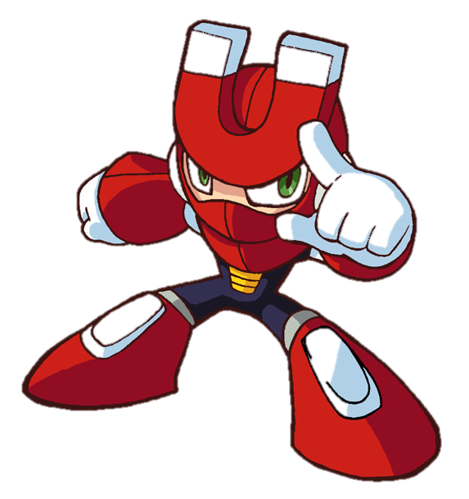

**Put your annotations into sentences.**

**Self portrait**

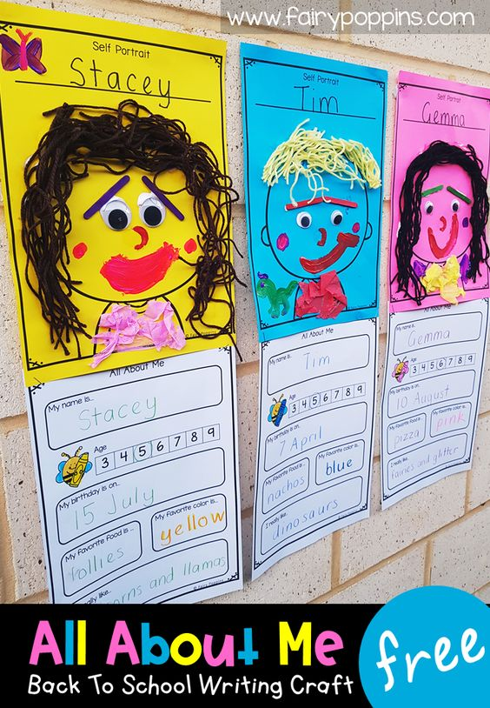

**Walking water experiment**

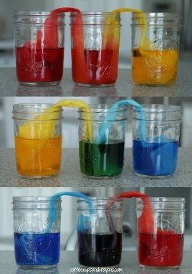

**Rock painting**

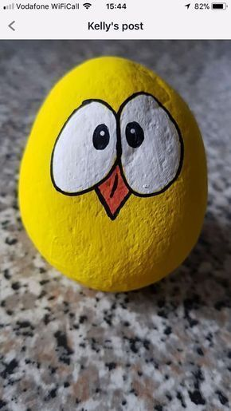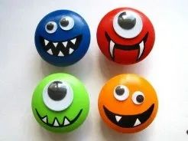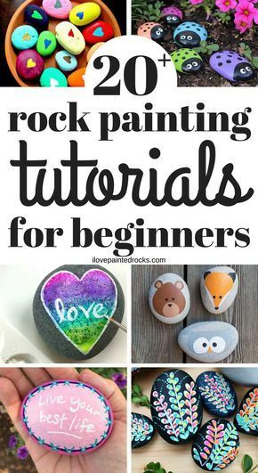

**Make a bouncy egg** 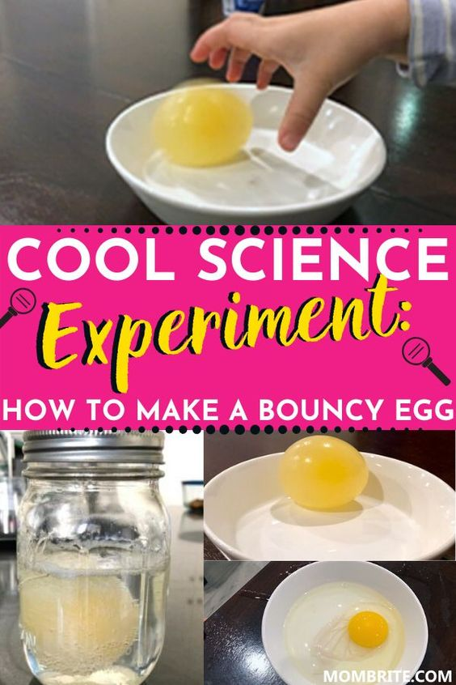

**Race time**

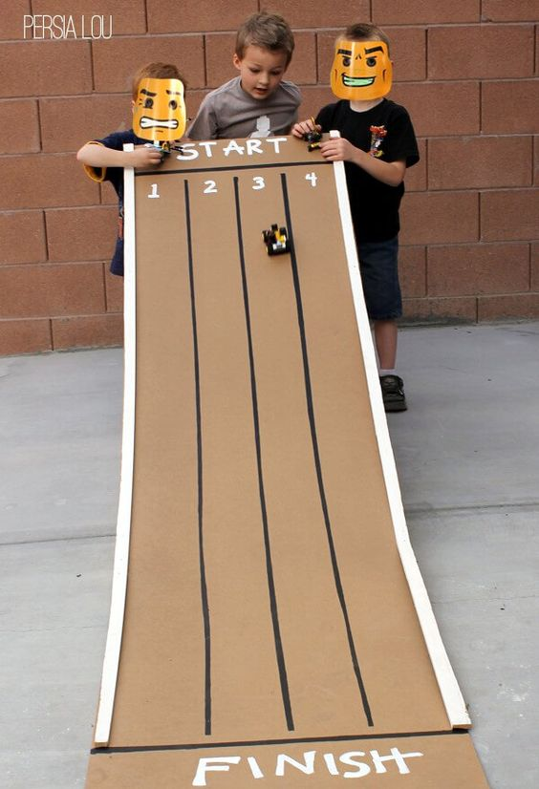 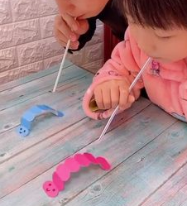 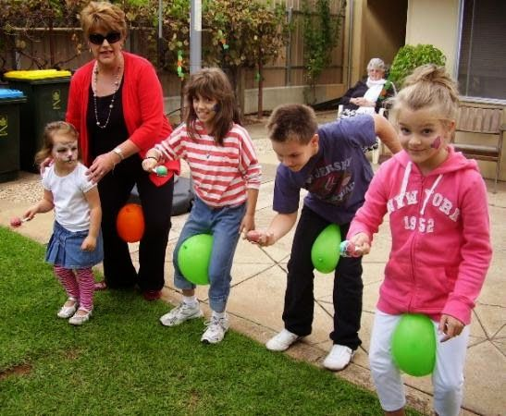

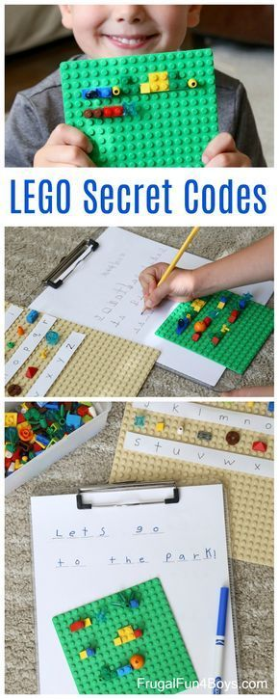Lego

Blank wordsearch

|  |  |  |  |  |  |  |  |  |  |
| --- | --- | --- | --- | --- | --- | --- | --- | --- | --- |
|  |  |  |  |  |  |  |  |  |  |
|  |  |  |  |  |  |  |  |  |  |
|  |  |  |  |  |  |  |  |  |  |
|  |  |  |  |  |  |  |  |  |  |
|  |  |  |  |  |  |  |  |  |  |
|  |  |  |  |  |  |  |  |  |  |
|  |  |  |  |  |  |  |  |  |  |
|  |  |  |  |  |  |  |  |  |  |