S.E.a.T.S.S
Specialist Education and Training Support Service

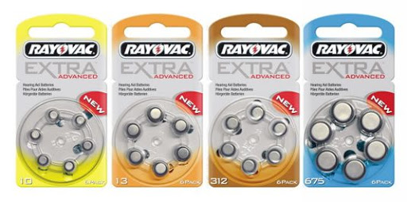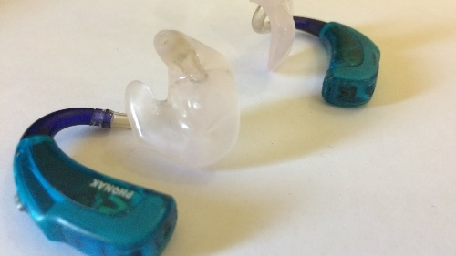

The Clinic the place to go.
Don’t run Low!!
Contact the clinic:
Hackney Audiology Tel: 02070147010
Email: BHNT.HackneyArkAudiology@nhs.net

Loxford Audiology Tel: 03003001580
Wood street Tel: 02084307830
Chapel End Tel: 02085019995
Email: bhnt.paediatricaudiologywx@nhs.net
Children Hearing aid Department (CHAD)
Email: uclh.enquiry.chad.rntne@nhs.net
Great Ormond Street Tel: 02078138430
Email: audiology.info@gosh.nhs.uk
Barking and Dagenham and Havering Tel: 03003001753 Email: Nem-tr.audiologyapptscfc@nhs.net Barking
Tel: 03003001786 Email: Nem-tr.audiologyapptshwc@nhs.net Harold Wood

SEATSS@redbridge.gov.uk
Tel: 07780164239

