This week’s story is: On the Bus

- Before reading the story practice your speedy sounds
- Story GREEN words & story RED words
- Begin to read the story
- Fred talk (sound out) the sounds to read the word
- Try your best to Fred in your head (sound out in your head) by the end of the week
- Answer the comprehension questions
- Do the green and red words spellings every day
- Your writing tasks will link to this book.
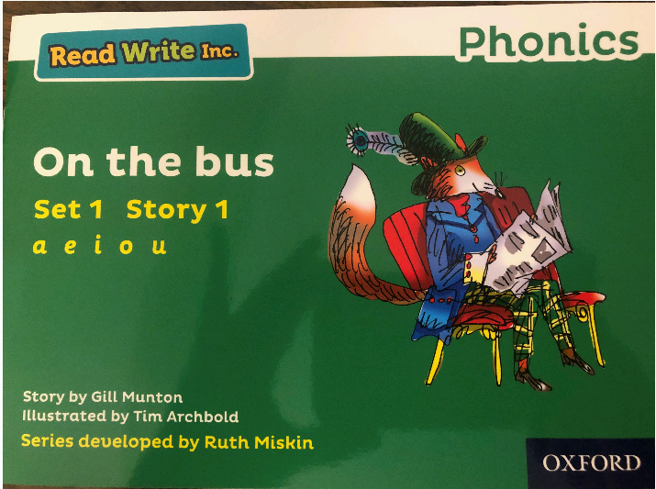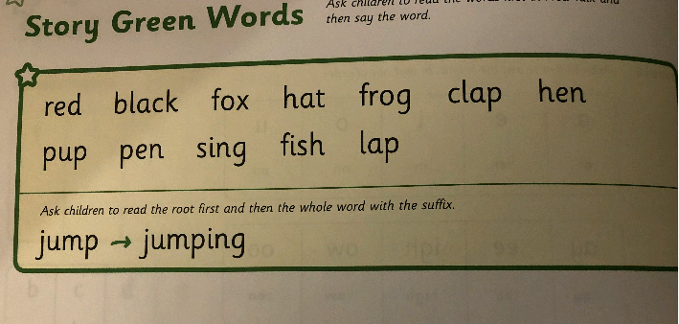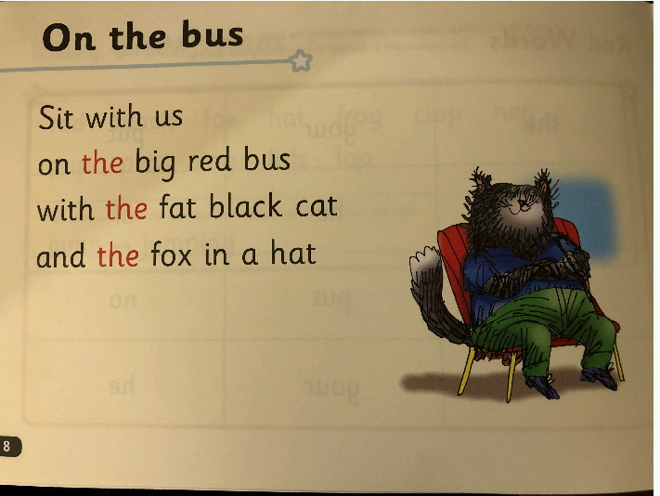PAGE 8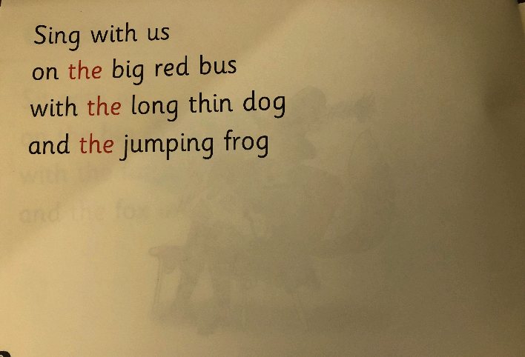PAGE 10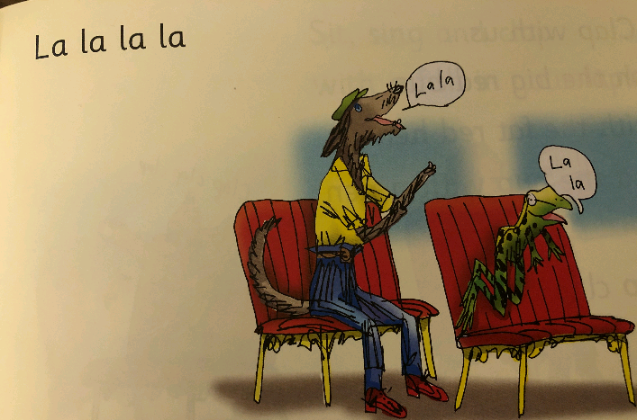PAGE 11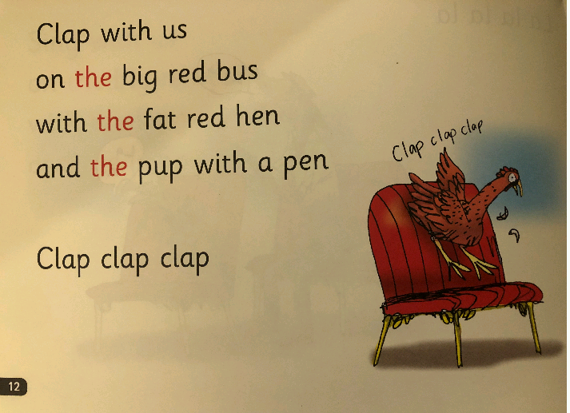PAGE 12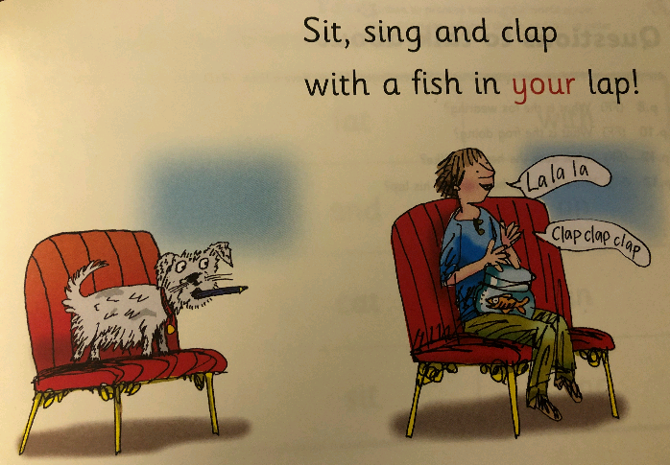PAGE 13

Reading comprehension questions
Turn to the page and use your FASTEST FINGER to find the answer.
What is the fox wearing? (Page 9)
What is the frog doing? (page 10)
What does the hen look like? (page 12)
What does the boy have in his lap? (page 13)

