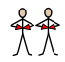
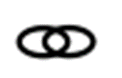
Level 1

Sit with us
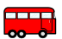
on the big red bus
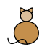
with the fat black cat
and the fox in a hat
Sing with us
On the big red bus
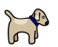
With the long thin dog
and the jumping frog

Clap with us
On the big red bus
With the fat red hen
And the pup with a pen

Level 2

____ with us
on the big red ___
with the fat black ___

and the fox in a ___
____ with us
On the big ___ bus
With the long thin ___

and the jumping ____

____ with us
On the ___ red bus
With the fat red ___
And the pup with a ___

Level 3

____ with __
__ the big red ___

with the ___ black ___

and the ___ in a ___
____ with __
__ the big ___ bus
With the ____ thin ___

and ___ jumping ____

____ with __
On the ___ red bus
With the fat red ___
And the pup with a ___

Level 4

____ with __
__ the ___ ___ ___

____ the ___ black ___

and the ___ __ a ___
____ ____ __
__ the ___ ___ bus
With the ____ ____ ___

and ___ _______ ____

____ ____ __
__ the ___ ___ ___
____ the ___ ___ ___
And the ___ ____ a ___

