A story about working at home

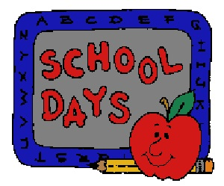
On Monday, Tuesday, Wednesday, Thursday and Fridays I usually go to school to do schoolwork and meet my friends.

Now school is closed so I have try to do school work at home and can’t see my friends.

I don’t have to do school work all day at home. Only for one or two hours a day.

My parent/carer will tell me when I have to do school work and I will do my best to do it when they tell me.

If I don’t understand it I can ask my parent/carer to help me.

I can play games or watch tv when I have finished my school work.

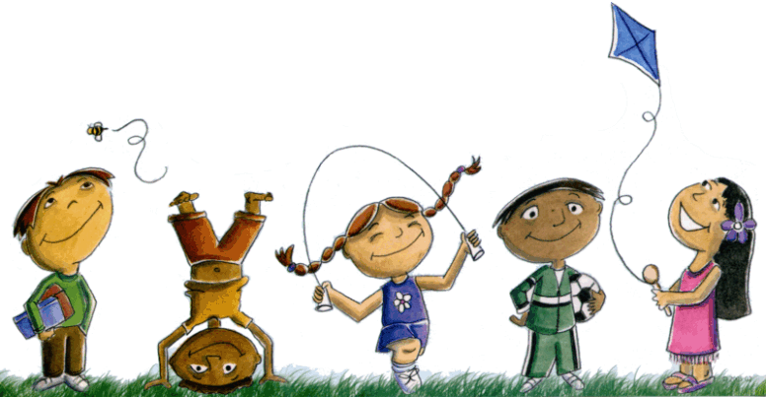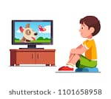
This Photo by Unknown Author is licensed under CC BY-NC-ND

I can speak with my friends and family on the phone or online to see how everyone is
doing.
This Photo by Unknown Author is licensed under CC BY-NC-ND

If I do this my parent/carer will be happy and when I go back to school I will be ready to learn again.
Back to school
This Photo by Unknown Author is licensed under CC BY-SA

